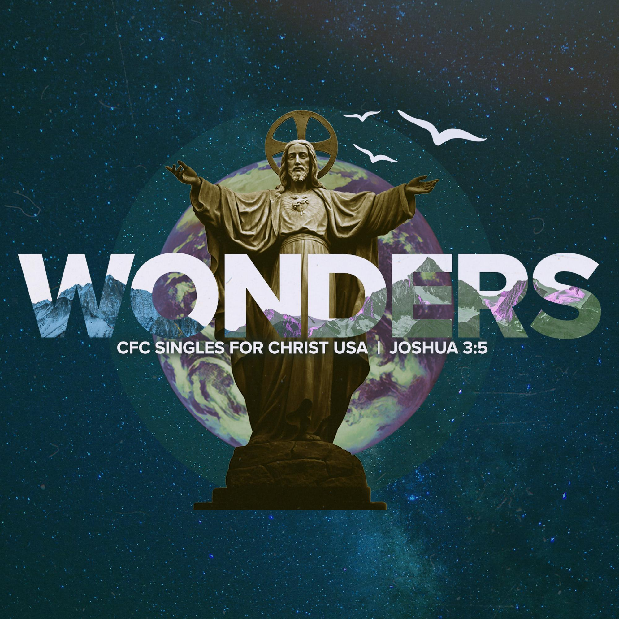
CFC-SFC 2021 YEARBOOK & SPONSORSHIP AGREEMENT
“Sanctify yourselves, for tomorrow the Lord will perform wonders among you.” - Joshua 3:5

We invite you to help commemorate the 27th CFC (Couples for Christ)-SFC (Singles For Christ) celebration in the United States, our 2nd SFC USA Conference held online.

This year, we will showcase a yearbook-style collection of photos and videos featuring CFC-SFC households and families throughout 2021. It is encouraged to include a bible verse or a short spiritual reflection in your photo or video.

Additionally, we are extending an opportunity for any businesses interested to submit advertisements. This collection will be available to be viewed online on the CFC-SFC USA website at https://www.cfcsfcusa.org/sponsors and https://www.cfcsfcusa.org/yearbook throughout the duration of the SFC USA Conference on September 25 - October 2, 2021.

☐ I (We), hereby authorize CFC–SFC Ministry to publish our group photo in full-color as part of the CFC-SFC 2021 Yearbook/Sponsorship Collection on the CFC-SFC USA website.

☐ SFC Yearbook - $10.00
☐ Business Sponsorship - $25.00

Name/Company/Organization: _________________________________________
Address: ___________________________________________________________
City: _______________________________ State: ___________ Zip: ___________
Phone: _____________________ Email: __________________________________
Region: ______________________________ ☐ Household ☐ Chapter ☐ Area

Please send your photo/video via email to conference@cfcsfcusa.org with subject line “Yearbook” or “Sponsorship.” Send payments via Zelle to conference@cfcsfcusa.org. Submission deadline is Friday, September 24, 2021. Inappropriate photos and videos will not be posted on the website.
Thank you for your support from CFC-SFC USA!

